Assignment 5.4

*Becca Buechle*

*August 4, 2020*

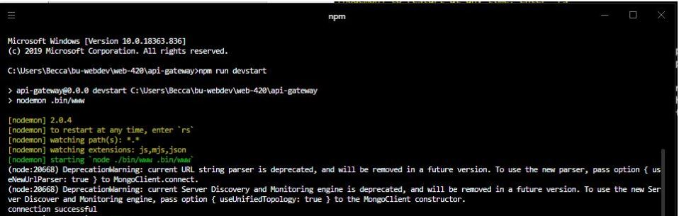

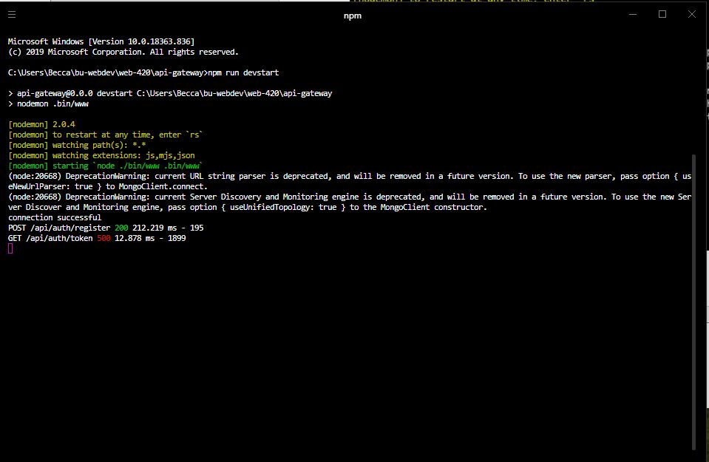

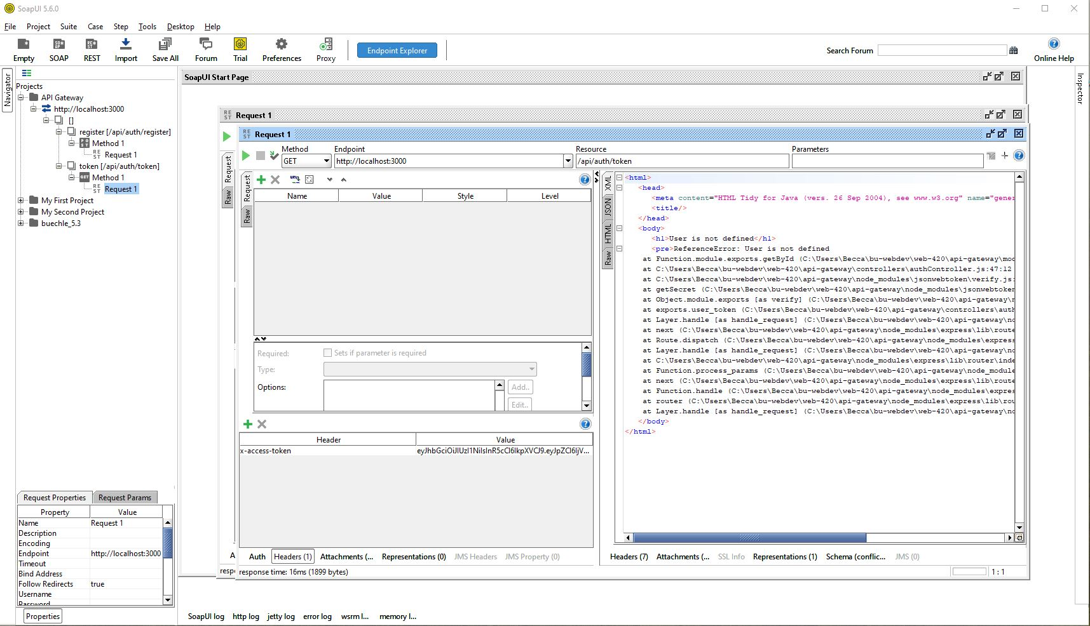

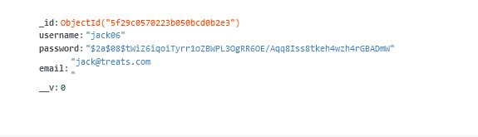

I followed the directions to a T and in SOAP it acted like it couldn’t preform this however, when I went into the MongoDB it did in fact add the new user.